Kol Simcha Torah Gazette
For parshas lech lecha 5786
Vol 10 Issue 6 (Whole #470) 10 Cheshvan 5786/ November 1, 2025
Printed L’illuy nishmas Nechama bas R’ Noach, a”h
For a free subscription, please forward your request to keren18@juno.com
Past emails can be found on the website ShabbosStories.com under Brooklyn Torah Gazette

Why the Simple Pine Casket?
By Rabbi Yehuda Shurpin


Art by Rivka Korf Studio

That’s a great question, one that makes perfect sense to an American Jew, since burial in a simple casket is de rigueur among those who follow Jewish tradition here in the US.
You may be surprised to learn that I recently fielded an entirely different question from a Jew in Israel. After reading about someone being buried in a pine coffin, he asked if caskets are allowed according to Jewish law.
You see, unlike in the Diaspora, the widespread custom in Israel is for the dead to be buried in the ground without any sort of coffin, with only their shrouds separating them from the earth. The use of any coffin is thus an anomaly for them.
What gives?

Burying the Dead in the Earth
Man is composed of a body and soul. As the verse in Genesis states, “The L-rd G-d formed man of dust from the ground, and He breathed into his nostrils the soul of life, and man became a living soul.”¹
The soul comes from G-d Himself, and when the person dies, his or her soul returns to its source. The same is true for the body, which must return to dust, as we read, “For dust you are, and to dust you will return.”²
The commandment to specifically bury the dead is reiterated in Deuteronomy, which tells us (regarding someone executed by the court) that “you shall bury him on that day.”³
Accordingly, the practice in Israel (and other places as well) is to bury the person directly in the ground, which is the ideal way of fulfilling the mitzvah.⁴

A Wooden Coffin
So where does the coffin enter the picture? In some locales, this is due to government regulations or for other reasons. But this is by no means a modern invention. The concept of using some sort of coffin is mentioned in the Bible regarding Joseph, as well as a number of times in the Talmud.⁵
But in order for the person to be buried in the dust, the coffin must be entirely buried in the ground.⁶ It is also customary to do some or all of the following: remove the bottom planks of the coffin prior to burial, drill holes in the bottom, and/or put earth in the coffin itself.⁷ Also, since the wooden coffin (often pine) grew from the ground and will easily return to it by disintegrating, it is still considered as if one was buried in the earth.⁸
These practices have precedence in the Talmudic tradition that Rabbi Judah the Prince (redactor of the Mishnah) instructed before his passing that he be buried in simple shrouds, and that holes be made in his coffin so that it would be opened to the earth.⁹

Not Shaming the Poor
There is another key reason why we make sure to specifically use a simple coffin with very few adornments, if any.
We find in the Talmud that there was a time when those who were wealthier would use more expensive materials, and the poor would use cheaper materials. The poor were embarrassed, so the rabbis instituted that the rich use the same materials as the poor. In the words of the Talmud:
Additionally, at first the wealthy would take the deceased out for burial on a dargash (a type of ornamental bed), and the poor would take the deceased out on a plain bier made from poles that were strapped together; and the poor were embarrassed. The sages instituted that everyone should be taken out for burial on a plain bier, due to the honor of the poor.¹⁰
The rule of using simple materials for the dead also applies to the other aspects of the funeral, such as using simple shrouds.

A Matter of Perspective
When one passes away from this world, he sheds his corporeal body, and the soul lives on in the spiritual worlds. In those worlds, only spiritual wealth has meaning; physical wealth is worthless. Thus, if one wants to bring true honor to the soul, the best thing to do would be to take any of the money that he would have used for a fancier or more expensive funeral, and use it for charity to support the learning of Torah and fulfillment of mitzvahs in the merit of the departed. This not only brings great merit, but is the greatest honor that the soul can have in the spiritual world.
Ultimately, however, we believe that the soul will once again be reunited with its physical body at the time of the Resurrection of the Dead. Thus, death and burial is only temporary, which is another reason why nothing fancy is needed.
May we merit the time when G-d will wipe away death and tears from this world, with the coming of Moshiach!

Footnotes
1. Genesis 2:7. 2. Genesis 3:19. 3. Deuteronomy 21:23. See also Mishneh Torah, Hilchot Avel 12:1.
4. See Shulchan Aruch, Yoreh De’ah 362:1. Incidentally, this is also one of the reasons for the prohibition of cremating the dead. For more on that, see Why Does Judaism Forbid Cremation?
5. See, for example, Jerusalem Talmud, Ketubot 12:3.
6. See Shulchan Aruch, Yoreh De’ah 362:1.
7. See, for example, Shach on Shulchan Aruch ad loc; Kitzur Shulchan Aruch 199:1.
8. See Radbaz on Mishneh Torah, Hilchot Avel 4:4.
9. Jerusalem Talmud, Ketubot 12:3. Some explain that his instruction was to actually remove the bottom planks (see Rabeinu Yerucham, Toldot Adam ve-Chavah 28).
10. Talmud, Moed Katan 27a–b.

Reprinted from the website of Chabad.org

Rav Avigdor Miller on
Fossils from the Great Flood

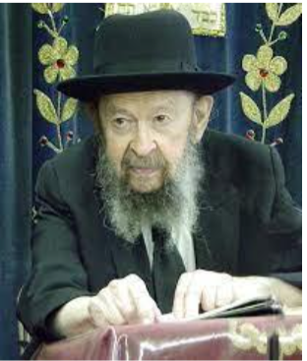

QUESTION: Did Adam HaRishon have many sons and daughters?
ANSWER: Yes. How many, I can’t tell you. He had many sons and daughters. They’re not named because they weren’t important enough to be named. Of course they were important, but the Torah doesn’t spend time just on the important things. It tells us only the most important things.
Now we know that during these long years of the old generations, they had very many children. And it is quite possible, it’s probable that they populated the entire world. All over the world their children spread. In 800 years, it is possible to have a whole nation of children. Your children have children and they have children; you can see great-great-great-great-grandchildren in 800 years. And they spread everywhere.
And therefore, it’s not surprising to us to find all kinds of human beings buried everywhere embedded in rocks as fossils all over the world, from the earliest times. When the Mabul came, the Mabul destroyed all of them and it laid down layers of sediment which genuine geologists testify were laid one after the other.
I’ll explain that. When there’s a flood of water, it carries a lot of sediment and the more violent the water is, the faster its current, the more it carries sediment with it. Now when the waters settle, it lays down a layer of sediment and that sediment, that’s what causes the rock to be created and whatever is inside that rock, human bodies, animal bodies, plants, become fossilized. The protein is carried away by the water, and minerals instead take their place. That’s how you have fossils.
Now, we see that the layers, the strata, lie one on top of the other without any sign of disturbance. Now if the second stratum would have been laid a long time after the first like the evolutionists claim, the surface of the bottom strata would have been eroded by winds and by rain, by currents, and there would have been unevenness. But when you see a stratum lies on top of a stratum with a perfect conformity, not the slightest sign of erosion, it means one was laid down right after the other. So, a current coming from this side lays down this kind of sediment, then when it stops, a current came from the other side and laid another kind of sediment, one on top of the other. And that’s proven, therefore, that these stratum were laid down one after the other in quick succession.
Not there were millions of years in between like the liars tell us. Because if even 100,000 years pass, even if 1,000 years pass, the surface of the stratum is eroded. The weather, winds and rains erode the surface. But since we find so many strata one on top of the other, even in the high mountain, it’s full of stratum, and it shows that they were all laid down one on top of the other immediately. And the only explanation was the Mabul.
So, at the time of the Mabul, mankind had spread all over the world because there had been very many people in the world because of the long lives of their forbearers. And when the Mabul came, they were buried under the sediments that the Mabul carried.
And therefore, we have fossils of men – modern men; not primitive men; real ordinary men, everywhere – only they don’t speak about them. It’s not considered newsworthy when a modern type man is discovered. When they find somebody who’s old and his knees are bent by arthritis and he walked stooped because of old age, oh, they found a primitive man who looks like a monkey!
But when they find a man who died with an erect stature and everything is as normal as we are, they don’t report it. But we have to know, however, that it’s well known that there are fossils of normal men everywhere. And that’s a result of the Mabul because in the time of the Mabul, mankind had spread all over the world.

Reprinted from a recent email of Torah Avigdor based on a lecture delivered on. October 1988).

The Darkness of Our Galus is a Descent for a Greater Aliyah
From the Teachings of the Lubavitcher Rebbe
Rabbi Menachem Mendel Schneerson, Zt”l

In the opening lines of this week's Torah portion, Lech Lecha, G-d commands Abraham to "go out" from his land, from his place of birth, to a land that G-d will show him. What can we to learn from this very first commandment to Abraham that can be applied to our own lives as well?
The first and most fundamental requirement of every Jew is to "go out" - to be in a constant state of ascent, developing and elevating both one's inner potential and one's surroundings.
But the very next thing that happened to Abraham after heeding this command appears to be the exact opposite of development and elevation: "And there arose a famine in the land, and Abraham went down into Egypt." Thus, Abraham had to leave Canaan and journey to Egypt, during which time Sarah was forcefully taken to Pharaoh's palace. Although G-d protected her from harm while there, she nevertheless underwent the hardship of the whole incident.
How does this obvious descent fit into the aforementioned theme of ascent and our task of climbing ever higher?
On a superficial level, Abraham's and Sarah's hardship was a step down, but on a deeper level it was merely a part of their eventual elevation and triumphant return. The purpose of the descent was to achieve an even higher ascent than was possible before. When they returned to Canaan they were "very heavy with cattle, with silver, and with gold."
Just as Abraham's descent was part of the greater plan of ascent, so it was the Jewish people of all generations. The Jewish people have found themselves thrust into exile after exile, only to return to their Land and achieve even higher spiritual heights than before. Galut (exile), although appearing to us to be a negative phenomenon, actually carries the potential for the highest good. And now that we are in the last moments of the final exile, we approach an era of unprecedented spirituality and goodness. For although the First and Second Temples were destroyed, the Third Temple is to stand forever, and our coming Redemption will have no exile to follow.
We therefore draw encouragement from our ancestor Abraham's descent into Egypt and eventual return to Israel: We must remember that the darkness that seems to prevail is only external, and is part of G-d's greater plan for the ultimate prevailing of good over evil and the coming of Moshiach.

Reprinted from the Parashat Lech Lecha 5763/2002 edition of L’Chaim, a publication of the Lubavitch Youth Organization. Adapted from the works of the Lubavitcher Rebbe.

Cash The Check!

After hearing about how wonderful and exalted Shabbos is, many people will surely ask, "I’ve been keeping Shabbos for many years. Why don't I have this experience?"
The answer may be understood through the following allegory: Someone goes to the doctor because of skin sores, and the doctor discovers that the underlying cause is a blood infection. The doctor treats the source of the infection, and the blood clears up. Now the person is completely healthy — the cause of his illness is gone.
Superficially he looks the same as before, as it will take a little while for the sores to go away, but inside he is already healed of his illness. When this person looks at himself, he doesn't believe he's healthy. His skin is full of sores! So, he ignores the doctor's orders to avoid certain foods that will cause the illness to return. He sees himself as still ill; therefore, he doesn't understand what he has to lose by eating these foods that he is accustomed to and enjoys. So, he continues consuming the harmful foods, and his illness indeed returns.
Shabbos is the summit of all the holy days. But after Shabbos a person goes back to life as usual, because he sees only what's on the outside. And superficially, nothing has changed; he feels he is the same person and doesn't see why he shouldn't continue doing the same things. Why should they now be harmful to him?
But if he could see inside, he would know a tremendous change has taken place. The underlying cause of all a person's troubles — his sins — was completely healed on Shabbos. Chazal say that on Shabbos evening, two ministering angels come and place their hands on a person's head and say to him, "Your iniquity is gone, and your sin is atoned for."
But it takes time until the healing reaches the outer levels. If a person believes he is now healthy, he would surely try to keep a safe distance from the cause of the illness: his sins. We could explain it another way: On Shabbos, a person receives a check. This check is full of kedushah and taharah. But everyone knows that a check must be cashed or deposited. If you don't do anything with it, a check is worthless.
A person who understands the value of the "check" he received on Shabbos will cash in on it and apply its value to his practical deeds and everyday life. A wise person will utilize its inner light in all that he does. Let us hurry to cash our check, before it's too late to use it! May Hashem help us hold onto the tremendous spiritual assets we gain through Shabbos Kodesh.

Reprinted from the Parshat Bereishit 5786 email of Toras Avigdor.

Thoughts that Count
for Our Parsha

Go out of your land... and I will make your name great (Gen. 12:1,2)
Why did G-d find it necessary to promise Abraham that his name would be great? Did Abraham really care about personal fame? Our Sages taught that the mention of Abraham's name caused G-d's name to be sanctified. Abraham's whole life was spent spreading the knowledge of the one G-d. Wherever he went he caused people to think about their Creator. Thus, whenever Abraham's name was mentioned, G-d's name was sanctified, too. (Likutei Sichot)

Abram took Sarai his wife... and the souls they had made in Charan (Gen. 12:5)
If all the scientists in the world attempted to create even a mosquito, they could not succeed in imbuing it with life. What then, is meant by "the souls they had made"? Rashi explains that this refers to those whom they "brought under the wings of the Divine Presence." Abraham spread the belief in one G-d among the men, and Sarai among the women; they are therefore credited with having "created" the new believers. (Midrash)

And Abram called there in the name of G-d (Gen. 13:4)
Our Sages taught: Do not read vayikra - "and he called," but rather vayakri - "and he caused others to call." Abraham erected a way-station for travelers in the middle of the desert, and taught each person who partook of his hospitality about the oneness of G-d. Abraham was not content to be the only one to call on G-d's name - he caused others to come to appreciate and thank G-d for His goodness.

The name Abraham
Rashi explains that the changing of Abraham's name from Avram, meaning "the father of Aram"-Mesopotamia-to Avraham, meaning "father of many nations," shows how our forefather transcended his previous level of spirituality and achieved a new level of service. As reflected in his name, Abraham was thus given the potential to elevate the entire world.

Reprinted from the Parashat Lech Lecha 5763/2002 edition of L’Chaim

Sustained by Faith:
The Hostages Clung to
Judaism in the Darkest Places
By Yehudis Litvak



Recently freed hostages are revealing extraordinary stories of courage, faith, and the unbreakable Jewish spirit that carried them through the darkest depths of captivity.
Matan Angrest: Tefillin in Gaza tunnels
Wounded and tortured, 20-year-old Israeli tank soldier Matan Angrest was dragged into Gaza, the only survivor from his tank crew after the October 7th Hamas attack. Throughout his two years of captivity, he stood up to his captors and asserted himself as a proud Jew.
Matan recalls, “I demanded tefillin, a prayer book, and a Tanakh. Somehow, they brought them. From that day on, I prayed three times a day — morning, afternoon, and night. It gave me strength. It protected me.”

As a soldier, Matan was subjected to especially severe torture. His mother, Anat, says, “He remembers being beaten so badly that he lost consciousness. They covered him with black sacks and dragged him away.” In addition to physical torture, Matan was subjected to psychological torture: he was told that Israel had given up on him, that Hamas was going to conquer Israel, and that his maternal grandparents were dead.
Upon his release, he was greatly relieved to discover that they were alive. Despite such brutal treatment, Matan refused to break, says Anat.
For most of his captivity, Matan was held with Gali Berman, who was also released in the recent ceasefire. Gali had a copy of the Torah and they read it together repeatedly. Matan says, “I know every Torah portion by heart.”
At one point, Matan was held together with Keith Siegel, who was released in a hostage deal in February 2025. Keith recalls that Matan maintained a positive attitude. He says, “Matan and I were held in a small, sealed room, without light. Matan kept a good mood, despite what he went through. We kept each other strong, and we laughed together.”
For the last four months of his captivity, Matan was held alone in a small, dark tunnel, under special guard. When asked how he managed alone in the tunnel, Matan replied, “I tried to remain optimistic. I sang to myself… I prayed three times a day. My faith strengthened me very much.”
Doctors at Ichilov Medical Center, where Matan recuperated for four days after his release, reported that despite severe physical wounds, Matan’s spirit remains strong.

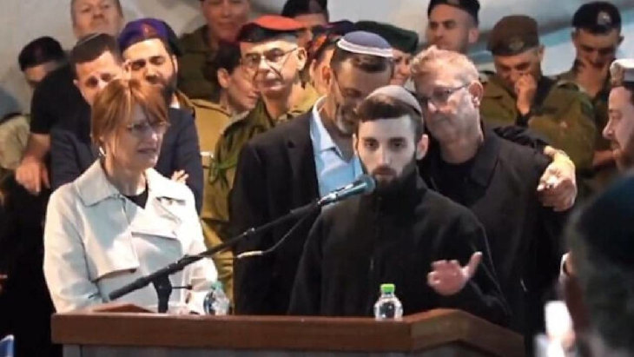Matan eulogizing his commander Daniel Peretz at his funeral

Two days after his return from Gaza, Matan told the IDF Chief of Staff Lt. Gen. Eyal Zamir that he would like to return to active duty in the IDF. That same day, Matan left the hospital to attend the funeral of his tank commander, Daniel Peretz, who was killed on October 7th. Peretz’s body was kidnapped by Hamas and returned as part of the ceasefire deal.
At Peretz’s funeral, Matan delivered a heartfelt eulogy and promised the family, “Everywhere I go, he will be with me always.” He also stated that he is ready to go back to Gaza to retrieve the body of another member of his tank crew, Itay Chen, that is still held by Hamas.
Matan’s faith sustained him throughout his ordeal and continues to guide him as he recovers. As he says, “Even in the deepest tunnels, the soul can’t be taken captive.”
Rom Braslavski: I am a Jew
Only 19 at the time of Hamas attack, Rom Braslavski refused to flee from the Nova festival, where he worked as a security guard. He stayed to help others escape, to take care of the wounded, and to prevent the terrorists from kidnapping the bodies of the dead. Rom fought terrorists by throwing rocks at them and encouraging others to do the same.
Rom’s mother, Tami, says, “He did not see fear. He did not see death. He only saw one thing: how he could help, encourage, and save as many people as possible.” Unfortunately, Rom’s rescue efforts were brought to an end by about 3 p.m., when he was captured by terrorists from the Islamic Jihad.

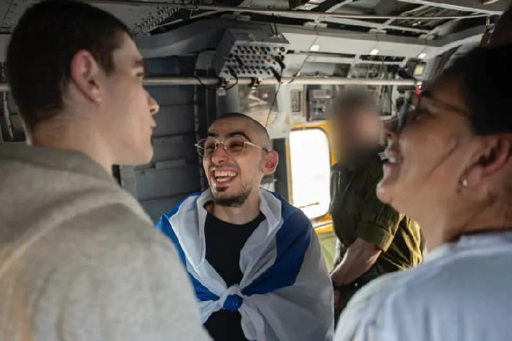

Throughout his two long years of captivity, Rom clung to his faith. Released hostage Sasha Trufanov, who was held together with Rom for some time, reported that Rom would begin each morning with reciting the Modeh Ani and Shema prayers, thanking G-d for keeping him alive.
In Gaza, Rom was held in harsh conditions, deprived of food and basic necessities. In the beginning, he was shackled by all four limbs in a tiny room and given only half a piece of dry flatbread and a bit of rice each evening.
Starving and desperate for food, one day Rom managed to break free of his shackles and tried to cook some pasta. The gas wasn’t working, so he started a fire with a book and some clothes he found in the apartment. Unfortunately, the neighbors smelled fire and banged on the windows. Afraid for his life, Rom hid under a bed as dozens of Gazans stormed into the apartment.
His mother says, “He felt them above the mattress. They saw the shackles, realized a hostage was there, and began searching.” Rom feared that he would be lynched by the angry mob. He remained in his hiding place, praying. Unexpectedly, his captor arrived, and the crowd dispersed. His captor did not punish him.
Rom’s captors also applied psychological torture, telling him that Iran had bombed Israel and nearly destroyed it and that 3,000 soldiers had died.
The captors also pressured Rom to convert to Islam, promising more food and better conditions. Rom absolutely refused, telling them, “I am a strong Jew!” His mother says, “Rom insisted on preserving his Jewish identity. The moment he came back, he put on tefillin.”
From the Sheba Medical Center, where Rom is recuperating, he recalls, “The only thing that gave me strength was knowing that everyone around me wasn’t Jewish, and that the reason I was there was simply because I’m a Jew.”
Rom’s message to the Jewish people is, “we need to go back to being a united people. People should start keeping mitzvot and understand what it means to be Jewish. Look at what happened to me, what they did to me, just because I’m a Jew. That means a Jew should understand he is in a higher place, different from someone who isn’t Jewish. We need to strengthen Judaism, and I hope the people of Israel remain united.”

Bar Kupershtein: Finding G-d in the darkest places
Like Rom, 21-year-old Bar Kupershtein worked as a security guard at the Nova festival and refused to abandon his post when Hamas attacked. A paramedic, Bar cared for the wounded and assisted in their evacuation until he was kidnapped and taken to Gaza.
In Gaza, Bar was starved, beaten, and tortured. His mother, Julie, shared, “He tells me the stories and I sit across from him crying, realizing my son is strong, a hero, and there’s no one like him in the world. He told me: ‘Mom, they beat me, but I didn’t feel it — my body was frozen.’ He said it was all in the mind, as if he trained his brain not to think about the pain at all — and he survived.”
Throughout this horrific ordeal, Bar never lost hope. He always tried to help others. Julie says, “He has golden hands. He fixed the electricity, dug the waste pit, built them a water channel, made a small area in the tunnel where they could sit alone when things were hard.”
Bar experienced many life-threatening situations and felt that he was saved by miracles. “He took upon himself a mitzvah of charity, and told himself that he had 200 shekels in his wallet at home, and when he got out of captivity he would donate it — and that would save him,” says Julie.

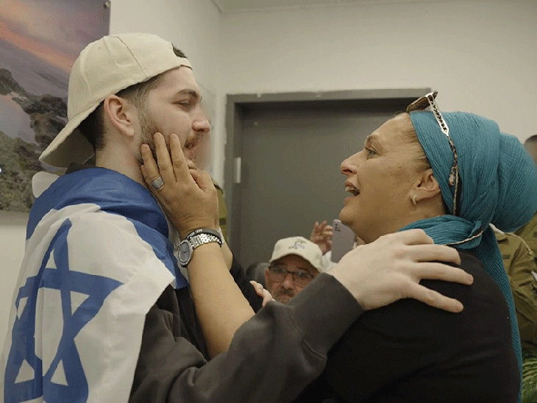

Bar tried to keep other mitzvot as well. This past Yom Kippur, he fasted and recited the prayers he remembered.
When he was released, he surprised his family by requesting a pair of tzitzit to wear. His mother shares that Bar’s connection to Judaism strengthened in captivity. Before, “[he] had faith, he was somewhat traditional — but not like [now]. There were Muslims there who prayed to the Creator as well, and they observed all the holidays and fasts, and he said if they’re doing it, then he also wants to be close to the Creator.”
Julie concludes, “A person in darkness, in the inferno — I think the first thing is to connect with the Creator, to try and save yourself somehow. He had a dialogue with G-d. He would say [the] Shema [prayer] often, he prayed, and recited a chapter of Psalms he knew by heart.”
Bar says that what gave him the most strength in Gaza was the song Afilu B’hastara, a favorite of his mother’s, written over two centuries ago by Rabbi Nachman of Breslov. The lyrics state that God is found even in the darkest places. In captivity, Bar used to sing this song to himself over and over again. After his release, a video circulated showing him singing this song together with his family.
In a powerful video message posted by StandWithUs, Bar addresses the world after his release. “I want to thank everyone who prayed, supported, and never gave up,” he says. “Most importantly, I want to thank the Creator of the World, our Father in Heaven.”
More Stories
Stories of other released hostages’ strength and faith are still coming out.
Eitan Horn, 37, of Kibbutz Nir Oz says that this year, he fasted on Yom Kippur for the first time in his life while held in Gaza tunnels.
Matan Zangauker found a worn book of Psalms in the tunnels and used it for daily prayer.
Segev Kalfon requested to watch the release ceremony of a fellow hostage, Ohad Ben Ami, in February 2025. Happy for Ohad, he pictured his own release ceremony, when he would stand on the stage, surrounded by terrorists, and shout the Shema prayer for the whole world to hear.
After his release, thankfully without a ceremony, Segev shared. “In the darkest place, I succeeded in seeing the light.” He tells of faith that sustained him throughout his captivity.
As the released hostages recover and speak out, we have much to learn from them.

Reprinted from the website of aish.com

